Hej 4c = bästa klassen,

Vi klassföräldrar vill bara påminna er om att vi har bokat ishallen i Diö nästa söndag den 20/1 mellan 16-18, hela familjen är hjärtligt välkomna

Tag gärna med fika, dryck, skridskor, ev klubba och glöm absolut inte hjälmen om du vill vara på isen ☺

Hoppas vi ses!

[](https://www.google.com/url?sa=i&rct=j&q=&esrc=s&source=images&cd=&cad=rja&uact=8&ved=2ahUKEwiK0P6_vOXfAhWDIlAKHd2QAn4QjRx6BAgBEAU&url=https://moranotes.tk/fototapeter/amne/skridsko/9/&psig=AOvVaw35WgHtgQlz4WbN_8A43Doz&ust=1547287279389420) [](https://www.google.com/url?sa=i&rct=j&q=&esrc=s&source=images&cd=&cad=rja&uact=8&ved=2ahUKEwjqv-_UvOXfAhXGY1AKHe2XBaEQjRx6BAgBEAU&url=https://www.zazzle.se/rolig%2Bhockey%2Bmusmattor&psig=AOvVaw2r2v7In8pnK8eK73aKGesA&ust=1547287322904529)

[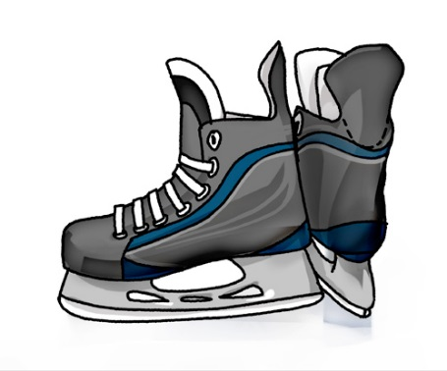](https://www.google.com/url?sa=i&rct=j&q=&esrc=s&source=images&cd=&cad=rja&uact=8&ved=2ahUKEwj_hveEvOXfAhWKZFAKHX5MBjQQjRx6BAgBEAU&url=https://elei-livetsresa.blogspot.com/2014/01/skridskor.html&psig=AOvVaw2iHUTSO05MCb4m8Q3VOPDH&ust=1547287169239718) [](http://www.google.com/url?sa=i&rct=j&q=&esrc=s&source=images&cd=&cad=rja&uact=8&ved=2ahUKEwjm8ZTpvOXfAhWSZ1AKHbIeAYAQjRx6BAgBEAU&url=http://annasarajohansson.blogg.se/2010/february/jag-ar-en-isprinsessa.html&psig=AOvVaw2WaPUTTFAHNqSSapcAFKVK&ust=1547287373855893)

[](https://www.google.com/url?sa=i&rct=j&q=&esrc=s&source=images&cd=&cad=rja&uact=8&ved=2ahUKEwjP4IOi6uXfAhVC-aQKHcH5ASUQjRx6BAgBEAU&url=https://www.hsb.se/molndal/brf/enerbacken/kalendarium/fika-och-idetraff/&psig=AOvVaw1y5SvJnjzYlzvfK-UJVB-2&ust=1547299568236710) [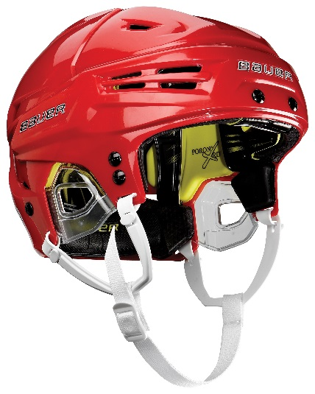](http://www.google.com/url?sa=i&rct=j&q=&esrc=s&source=images&cd=&cad=rja&uact=8&ved=2ahUKEwizo6zLveXfAhXFJ1AKHYIYDAkQjRx6BAgBEAU&url=http://news.cision.com/se/bauer/i/re-akt-high,c143989&psig=AOvVaw27RNI64U_4UIwEuGzncjeQ&ust=1547287544208611)